Human-induced changes in the hydrology of the western United States
Revised version submitted to the journal Science January 10, 2008
Tim P. Barnett¹, David W. Pierce¹, Hugo G. Hidalgo¹, Celine Bonfils², Benjamin D. Santer², Tapash Das¹, Govindasamy Bala², Andrew W. Wood³, Toru Nozawa⁴, Arthur A. Mirin², Daniel R. Cayan¹, Michael D. Dettinger¹

¹Scripps Institution of Oceanography
University of California San Diego
La Jolla, CA 92093

²Lawrence Livermore National Laboratory
Livermore, CA 94550

³Land Surface Hydrology Research Group
Civil & Environmental Engineering
University of Washington
Seattle, WA 98195

⁴National Institute for Environmental Studies
16-2, Onogawa, Tsukuba, Ibaraki, 305-8506, JAPAN

Accepted for Publication January 23, 2008
Abstract
Observations have shown the hydrological cycle of the western U.S. changed significantly over the last half of the twentieth century. Here we present a regional, multivariable climate-change detection and attribution study, using a high-resolution hydrologic model forced by global climate models, focusing on the changes that have already affected this primarily arid region with a large and growing population. The results show up to 60% of the climate related trends of river flow, winter air temperature and snow pack between 1950-1999 are human-induced. These results are robust to perturbation of study variates and methods. They portend, in conjunction with previous work, a coming crisis in water supply for the western United States.
Water is perhaps the most precious natural commodity in the western United States. Numerous studies indicate the hydrology of this region is changing in ways that will negatively impact the region (1, 2, 3). Between 1950 and 1999 there was a shift in the character of mountain precipitation, with more winter precipitation falling as rain instead of snow (2, 4, 5), earlier snow melt (6, 4), and associated changes in river flow (7, 8, 9, 10). In the latter case, the river flow experiences relative increases in the spring and relative decreases in the summer months. These effects go along with a warming over most of the region that has exacerbated these drier summer conditions (8, 11, 5).
The west naturally undergoes multi-decadal fluctuations between wet and dry periods (12). If drying from natural climate variability is the cause of the current changes, a subsequent wet period will likely restore the hydrological cycle to its former state. But global and regional climate models forced by anthropogenic pollutants suggest human influences could have caused the shifts in hydrology (2, 13, 14, 15). If so, these changes are highly likely to accelerate, making modifications to the water infrastructure of the western U.S. a virtual necessity.
In this paper, we demonstrate statistically that the majority of the observed low frequency changes in the hydrological cycle (river flow, temperature, and snow pack) over the western U.S. from 1950-1999 are due to human-caused climate changes from greenhouse gases and aerosols. This result is obtained by evaluating a combination of global-climate and regional-hydrologic models, and sophisticated data analysis. We use a multivariable detection and attribution (D&A) methodology (16, 17, 18) to show the simultaneous hydro climatic changes observed already differ significantly in length and strength from trends expected due to natural variability (detection), and differ in the specific ways expected of human-induced effects (attribution). Focusing on the hydrological cycle allows us to assess the origins of the most relevant climate-change impacts in this water-limited region.
We investigate simultaneous changes from 1950-1999 (20) in snow pack (snow water equivalent or SWE), the timing of runoff of the major western rivers, and average January through March daily minimum temperature (JFM T_{MIN}) in the mountainous regions of the western U.S. (19). These three variates arguably are among the most important metrics of the western hydrological cycle. By using the multivariable approach we obtain greater signal to noise ratio than from univariate D&A alone (see below).
The SWE data are normalized by October-March precipitation (P) to reduce variability from heavy or light precipitation years. Observed SWE/P and temperature were averaged over each of nine western mountainous regions (Fig. 1) to reduce small spatial scale weather noise. The river flow variate is the center of timing (CT), the day of the year one half of the total water year flow has occurred, computed from naturalized flow in the Columbia, Colorado and Sacramento/San Joaquin rivers. CT tends to decrease with warming due to earlier spring melting.
Selected observations from these regions/variables are displayed in Fig. 2, showing the trends noted above, along with substantial regional differences and “weather noise.” SWE/P trends in the nine regions vary from -2.4 to -7.9% per decade, except in the southern Sierra Nevada where the trend is slightly positive. The JFM T_{MIN} trends are all positive and range from 0.28-0.43°C/decade, while the river CT arrives between 0.3 to 1.7 days/decade earlier. The challenge in D&A analysis is to determine whether a specific, predetermined signal representing the response to external forcing is present in these observations.
We compared the observations with results from a regional hydrologic model forced by global climate model runs. One of the global models, the Parallel Climate Model (PCM) (21), has been used previously in hydrological studies in the western U.S. (22) and realistically portrays important features of observed climate and the amplitude of natural internal variability. The second climate model, the anthropogenically forced medium resolution MIROC (23, 24, 25), was selected from the current IPCC AR4 set of global runs (26) because it had available many 20th century ensemble members with daily data, and because of its high degree of realism in representing the Pacific Decadal Oscillation (PDO). We used the anthropogenically forced versions of these models to obtain an estimate the expected signal not confounded by other forcing mechanisms. The models provided multiple realizations (10 for MIROC, and 4 for PCM) of the historical response of the climate system to anthropogenic forcing. The daily output from these coarse horizontal-resolution model results was downscaled to a 1/8° × 1/8° latitude/longitude grid by two different statistical methods (Bias Correction and Spatial Disaggregation, BCSD (27) and Constructed Analogues, CA (28)). The downscaled temperature and precipitation data were supplied as input to the Variable Infiltration Capacity, (VIC) hydrological model, (27, 29, 15)) to obtain river flow and SWE/P.
We used the downscaled model results to estimate an anthropogenic “fingerprint” for the PCM and MIROC models (30). The fingerprint describes the joint variability of SWE/P, JFM T_{MIN}, and river flow (see Fig. 3 and 19). The model fingerprints are very similar in spite of the different external forcings used (26, 19). The results show that warmer temperatures accompany decreases in SWE/P and decreases in CT of major western river systems. The sign of each variable is a monopole, indicating a coherent regional-scale signal over the western U.S.
The temporal component of the fingerprint (not shown) is well-represented by a simple trend. This implies the fingerprint primarily captures the spatial expression of long-term changes, and not shorter-period climate modes (such as ENSO or the PDO).
The signal strength is calculated as the least-squares linear trend of the projection of a data set (model or observations) onto the fingerprint (see supplemental information for details). Fig. 4 (upper) shows the ensemble mean signals for our various model runs and the observations (19). The observations show a positive signal indistinguishable from the PCM and MIROC anthropogenically-forced runs. These signals exclude zero at the 95% confidence interval, thus achieving “detection”.
We used 1600 years of downscaled control run data from two different global models (19) to estimate the probability that the observed signal could be due to natural, internal variability (Fig. 4, lower panel). The observed signal falls outside the range expected from natural variability with high confidence (p < 0.01). In separate analyses for both PCM and MIROC, the likelihood that the model signal arises from natural internal variability is between 0.01 and 0.001 (19). The different downscaling methods have little impact on these results. We conclude natural internal climate variability alone cannot explain either the observed or simulated changes in SWE/P, JFM T_{MIN}, and CT in response to anthropogenic forcing.
PCM simulations forced solely by the combined impacts of observed solar variability and volcanic activity (Sol/Vol, Fig. 4) show a signal with sign opposite to that observed. We conclude solar and volcanic forcing also fail to explain the observed hydrological changes.
Might anthropogenically-induced precipitation changes account for our results? This is unlikely since our variables are chosen to minimize sensitivity to precipitation fluctuations. However, previous work has identified an anthropogenic effect on global-scale changes in precipitation (31). We conducted a univariate D&A analysis on precipitation, comparing the fingerprint obtained from the anthropogenic runs to the control runs and observations. The results (Fig. 4, lower) show that the observed changes in precipitation over the nine western U.S. mountain regions are indistinguishable from natural variability. We found the same for model precipitation (not shown). We conclude that while precipitation may be affected by anthropogenic forcing on larger scales or in other regions, or in this region in the future, it cannot explain the strong changes in western U.S. hydrology from 1950-1999.
Finally, the observations are consistent with the anthropogenic model runs. The observed signal is stronger than found in either model, but the differences are not statistically significant. The ensemble mean signal strength from PCM is 60% of the observed signal strength, i.e., PCM estimates three-fifths of the projected trend can be ascribed to human effects. The two downscaling methods give somewhat different signal strengths (Fig. 4), but the attribution holds no matter which is chosen. We conclude that application of a rigorous, multivariable D&A methodology shows a detectable and attributable signature of human effects on western hydrology.
We examined the time evolution of signal and noise by projecting the observations (signal) and control run data (noise) onto the multivariable fingerprint, then fitting linear trends of increasing length L to the resulting projected time series. This enables us to calculate a signal-to-noise (S/N) ratio as a function of L (from 10 to 50 years) Fig. 5 shows the S/N ratio rises above the 5% significance threshold no later than 1986. This result is robust to uncertainties in the model fingerprint, model-based noise estimates, and statistical downscaling method (19). We also repeated the D&A analysis without areal weighting, and found it made no difference to our conclusions.
The variables examined here co-vary in a physically and internally-consistent way: an increase in minimum temperature is associated with less SWE/P and earlier runoff. Quantitatively, we also compared the S/N obtained from separate analyses of each variable with that obtained for the full multivariable problem (19). For fixed choices of fingerprint, noise, and downscaling (32), the S/N from the separate SWE/P, JFM T_{MIN} and CT analyses were 3.46, 3.00 and 1.91, respectively, all significant at about the 0.05 level or above. The multivariable analysis had a S/N of 3.60, and so has quantitative value as well as providing a test of whether SWE/P, JFM T_{MIN}, and CT co-vary in a physically consistent way.
In summary, our results are robust with respect to uncertainties in model estimates of anthropogenic climate fingerprints and natural variability, downscaling method, and the choice of univariate or multivariate D&A analysis. Estimates of natural variability used for significance testing agree well with those derived from paleo proxies (19). The analyses show with high confidence that the majority of the detrimental changes already seen in western U.S. hydrology are caused by human-induced effects. PCM, which has the most realistic signal strength, shows human effects account for 60% of the observed 1950-99 trend in signal strength. MIROC accounts for 35% of the trend. Based on Fig. 4 (upper) and the discussion of MIROC in the supporting material, the PCM number seems more reliable.
Our results are not good news for those living in the western United States. The scenario for how western hydrology will continue to change has already been published using one of the models employed here (PCM; 2) as well as in other recent studies of western US hydrology (15, 33, 34). It foretells of water shortages, lack of storage capability to meet seasonally changing river flow, transfers of water from agriculture to urban uses and other critical impacts. A more recent study puts the timing of this impact within the next 10-20 years with high probability (35). Since PCM performs so well in replicating the complex signals of the last half of the 20th century, we have every reason to believe its projections and to act on them in the immediate future.
List of Figures

Figure 1. Location map showing averaging regions over which SWE/P and JFM Tmin were determined. The hatching shows the approximate outline of the three main drainage basins used in this study.

Figure 2. Observed time series of selected variables (expressed as unit normal deviates) used in the multi variate detection and attribution analysis. Taken in isolation, seven of nine SWE/P, seven of nine JFM Tmin, and one of the three river flow variables have statistically significant trends.

Figure 3. Fingerprints from the multivariate analysis of PCM and MIROC.

Figure 4. Ensemble average signal strength (upper, standard deviations of the fingerprint’s principal component per decade) and percentile rank of ensemble mean signal strength for the indicated model runs with respect to the combined (CCSM3-FV and PCM) control run (lower). Percentile values calculated by Monte Carlo resampling of the control run taking into account N, the varying number of ensemble members. PCM (BCSD) and PCM (CA): PCM runs with anthropogenic forcing, with two different downscaling methods as described in the text (N=4). MIROC: MIROC runs with anthropogenic forcing (N=10). Sol/Vol: PCM runs with only solar and volcanic forcing included (N=2). The cross shows the signal strength obtained from the observations (N=1). For comparison purposes, also shown is the observed signal strength from a separate analysis of precipitation changes over the nine mountain regions (diamond). Values outside the hatched and crosshatched regions are significant at the 0.01 and 0.05 level, respectively.

Figure 5. Time dependent S/N estimates for two different estimates of natural variability. The x-axis is the last year of L-length linear trend in the signal estimate.

References and Notes

1. P. Gleick, Water Resour. Res. 23, 1049 (1987).
2. ACPI, The Accelerated Climate Prediction Initiative, Climate Change 62 (2004).
3. B. Udall, G. Bates, Intermountain West Climate Summary, Western Water Assessment. Jan., Available from Univ. Colorado (2007).
4. A. F. Hamlet, P. W. Mote, M. P. Clark, D. P. Lettenmaier, J. Climate 18, 4545 (2005).
5. N. Knowles, M. D. Dettinger, D. R. Cayan, J. Climate 19, 4545 (2006).
6. P. W. Mote, A. F. Hamlet, M. P. Clark, D. P. Lettenmaier, Bull. Amer. Met. Soc. 86, 39 (2005).
7. M. D. Dettinger, D. R. Cayan, J. Climate 8, 606 (1995).
8. D. R. Cayan, S. Kammerdiener, M. D. Dettinger, J. Caprio, D. Peterson, Bull. Amer. Meteor. Soc. 82, 399 (2001).
9. I. T. Stewart, D. R. Cayan, M. D. Dettinger, J. Climate 18, 1136 (2005).
10. S. K. Regonda, B. Rajagopalan, M. Clark, J. Pitlick, J. Climate 18, 372 (2005).
11. P. Y. Groisman, R. W. Knight, T. R. Karl, D. R. Easterling, B. Sun, J. H. Lawrimore, J. Hydrometeorology 5, 64 (2003).
12. Colorado River Basin Water Management: Evaluating and Adjusting to Hydroclimatic Variability (National Academy of Sciences, Washington, D. C., 2007).
13. P. Milly, A. Dunne, A. Vecchia, Nature 438, Doi:10.1038 (2005).
14. R. Seager et al., Science 316, 1181 (2007).
15. N. Christiansen, D. Lettenmaier, Hydrol. Earth Syst. Discuss. 3, 1 (2006).
16. T. P. Barnett, M. Schlesinger, J. Geophys. Res. 92, 14772 (1987).
17. B. D. Santer et al., Climate Dyn. 12, 77 (1995).
18. R. Schnur, K. I. Hasselmann, Climate Dyn. 24, 45 (2005).
19. Methods are available as supporting material on SCIENCE Online.

20. Note this period excludes the large scale changes in runoff, precipitation and water storage that has occurred in the southwest, especially the Colorado River drainage, since 2000. We do not claim that the large changes since 2000 are necessarily the result of human-induced warming.
21. W. Washington et al., Clim. Dyn. 16, 755 (2000).
22. T. P. Barnett et al., Climate Change 62, 1 (2004).
23. K-1 model developers, “K-1 coupled model (MIROC) description,” (K-1 technical report 1, H. Hasumi and S. Emori eds., Center for Climate System Research, University of Tokyo, 2004).
24. T. Nozawa et al., Geophys. Res. Lett., 32, L20719, doi:10.1029/2005GL023540 (2005).
25. T. Nozawa et al., “MIROC, CGER's Supercomputer Monograph Report 12,” (Center for Global Environmental Research, National Institute for Environmental Studies, Tsukuba, Japan, 2007).
26. B. D. Santer et al., Proc. Natl. Acad. Sci. 104, 15248 (2007).
27. A. Wood et al., Climate Dyn. 16, 755 (2004).
28. H. G. Hidalgo, M. D. Dettinger, D. R. Cayan, J. Climate in review.
29. X. Liang, D. Lettermaier, A. Wood., S. Burges, J. Geophys. Res., 99(D7), 14415 (1994).
30. T. P. Barnett et al., Science 309, 284 (2005).
31. X. Zhang et al., Nature doi:10.1038/nature 06025 (2007).
32. The choices were PCM noise for normalization, CCSM3-FV noise for significance testing, PCM fingerprint and statistical downscaling with the CA method.
33. E. L. Miles, A. K. Snover. Chapter 11 in A. K. Snover, E. L. Miles, and the Climate Impacts Group, Rhythms of Change: An Integrated Assessment of Climate Impacts on the Pacific Northwest, Cambridge, Massachusetts: MIT Press, in review.
34. D. R. Cayan, E. P. Maurer, M. D. Dettinger, M. Tyree, K. Hayhoe, Climatic Change, in press.
35. T. P. Barnett, D. W. Pierce, Water Resources. Research, submitted
36. This work was supported by the Lawrence Livermore National Laboratory through an LDRD grant to the Scripps Institution of Oceanography (SIO) via the San Diego Super Computer Center (SDSC) for the LUCSiD project. The MIROC data was generously supplied by the National Institute for Environmental Studies Onogawa, Tsukuba, Ibaraki, JAPAN. The PCM simulation had previously been made available to SIO by the National Center for Atmospheric Research for the ACPI project. This work was also partially supported by Dept of Energy and NOAA through the International Detection and Attribution Group. The LLNL participants were supported by DOE-W-7405-ENG-48 to the Program of Climate Model Diagnoses and Intercomparison (PCMDI). The USGS and SIO provided partial salary support DC and MD at SIO; the California Energy Commission provided partial salary support for DP and HH at SIO.

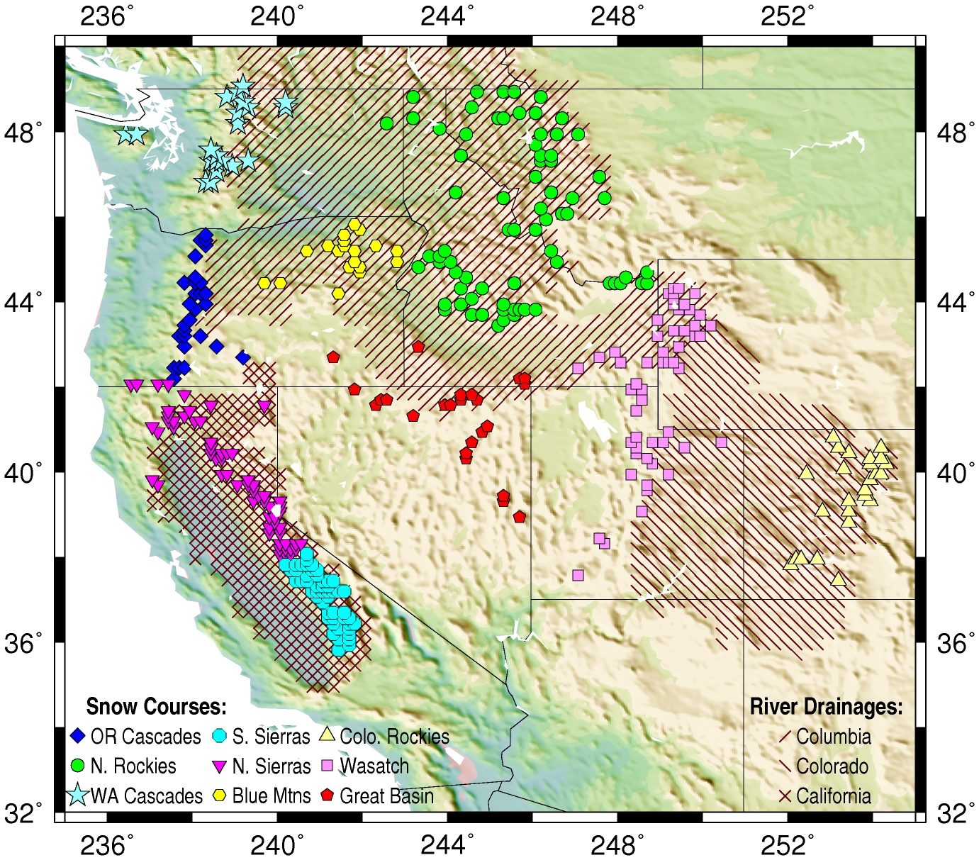
Figure 1. Location map showing averaging regions over which SWE/P and JFM Tmin were determined. The hatching shows the approximate outline of the three main drainage basins used in this study.
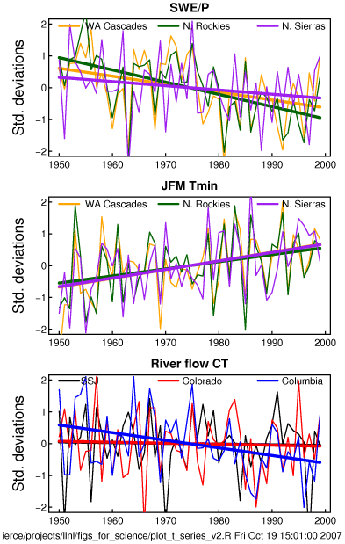
Figure 2. Observed time series of selected variables (expressed as unit normal deviates) used in the multi variate detection and attribution analysis. Taken in isolation, seven of nine SWE/P, seven of nine JFM Tmin, and one of the three river flows variables have statistically significant trends.
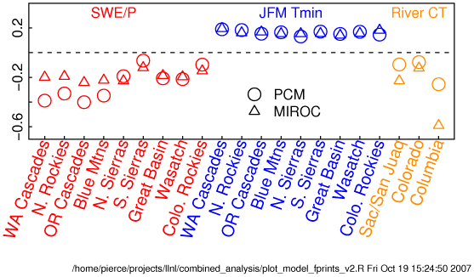
Figure 3. Fingerprint loadings from the multivariable analysis of PCM and MIROC.
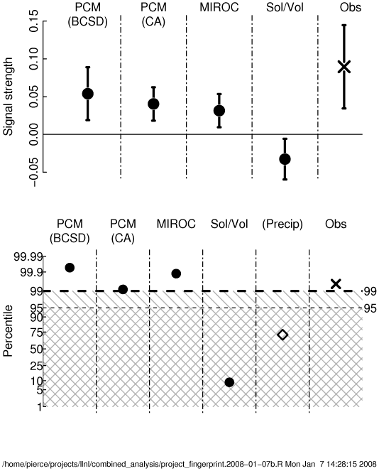
Figure 4. Ensemble mean signal strength (upper, standard deviations of the fingerprint’s principal component per decade) and percentile rank of ensemble mean signal strength for the indicated model runs with respect to the combined (CCSM3-FV and PCM) control run (lower). Percentile values calculated by Monte Carlo resampling of the control run taking into account N, the varying number of ensemble members. PCM (BCSD) and PCM (CA): PCM runs with anthropogenic forcing, with two different downscaling methods as described in the text (N=4). MIROC: MIROC runs with anthropogenic forcing (N=10). Sol/Vol: PCM runs with only solar and volcanic forcing included (N=2). The cross shows the signal strength obtained from the observations (N=1). For comparison purposes, also shown is the observed signal strength from a separate analysis of precipitation changes over the same region (diamond). Values outside the hatched and crosshatched regions are significant at the 0.01 and 0.05 level, respectively.
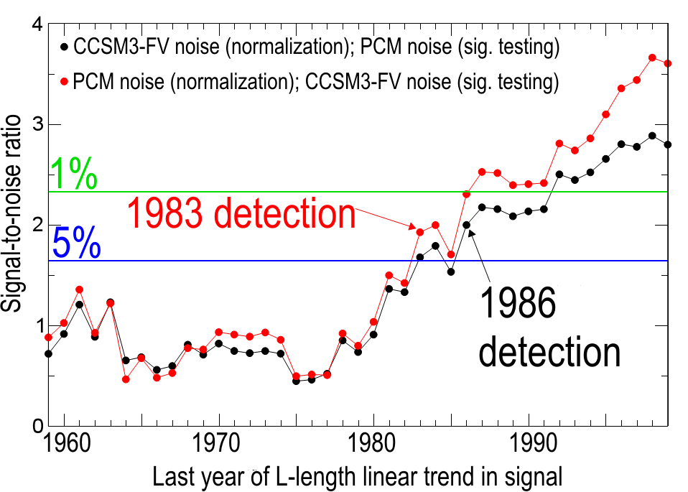
Figure 5. Time dependent S/N estimates for two different estimates of natural variability. The x-axis is the last year of L-length linear trend in the signal estimate.

Supporting Materials and Methods for “Human-induced changes in the hydrology of the western United States”

Tim P. Barnett, David W. Pierce, Hugo G. Hidalgo, Celine Bonfils, Benjamin D. Santer, Tapash Das, G. Bala, Andrew W. Wood, Toru Nozawa, Arthur A. Mirin, Daniel R. Cayan, Michael D. Dettinger

1. Data
The analysis uses observed snow water equivalent (SWE) at the beginning of April, precipitation (P), temperature, and naturalized river flow. The SWE data are from snow courses across the western U.S., obtained from the U.S. Department of Agriculture National Resources Conservation Service and from the California Department of Water Resources California Data Exchange Center. We selected a fixed subset of ~660 snow course sites that had at least 80% data coverage between 1950 and 1999. To exclude the possibility that our results would be biased by selecting stations that had all the missing values at the beginning of the period, we only included stations that had data in 1950 AND at least 80% coverage between 1950 and 1959 (inclusive), in addition to the overall requirement of 80% coverage between 1950 and 1999.

For temperature (JFM daily minimum, Tmin) and precipitation we used a gridded data set based on National Weather Service co-operative network observations (1). For naturalized river flow in the three major western drainages, we used data from the US geological Survey (2) and the U.S. Bureau of Reclamation. Details regarding all these data sets are given in (3), (4), and (5), respectively.

We regionally averaged the SWE/P and temperature data to nine major mountain chains in the western U.S. The main reason for doing this is to average random weather fluctuations across multiple locations. With ~660 snow courses and 9 regions, there are dozens of courses in each region, which helps minimize the noise. The exact regions chosen are arbitrary, but guided by traditional geographic features such as commonly recognized mountain ranges and state boundaries. The intent was to have the regions be identifiable to the inhabitants, and neither so large as to be irrelevant nor so small as to be of local concern only, since our desire was to illustrate how climate change might actually affect people.

2. Univariate D&A
We applied a univariate detection and attribution (D&A) analysis to each of the individual variates – SWE/P, JFM daily Tmin, and river flow center of timing (CT). The separate analyses were necessary to address the unique characteristics of each data type. The D&A work on air temperature is covered in (4), river flow by (5) and snow water equivalent by (3). These research efforts provide the foundation for the multivariable results presented here.

3. Climate model data
The anthropogenic runs in PCM and MIROC have significant differences in external forcings. Both PCM and MIROC use anthropogenic forcings of greenhouse gases, ozone, and the direct effect of sulfate aerosols. In addition to these, MIROC includes the indirect effect of sulfate aerosols, direct and indirect effect of carbonaceous aerosols, and land-use change as additional anthropogenic forcings. The indirect effect of aerosols, which give a cooling effect, is the most influential among them, although there is still large uncertainty in quantitative estimates of its radiative forcing. For example, see Fig.2.24 of the IPCC AR4 of WG1 ((6), available from IPCC web site). This results in the fact that the MIROC climate warming signal, while having a fingerprint quite similar to that of PCM and of the observations, is weaker. The physics resulting in this relatively cooler signal are highly uncertain, and observations in fact suggest that the aerosol forcing term is over estimated in the MIROC model.

Estimates of natural internal climate variability were obtained from two long pre-industrial control runs: a 750 year run of PCM and an 850 year run from the CCSM3-FV (7). CCSM3-FV was spun up for 240 years before use. These models were selected for their combination of exhibiting a realistic climate and level of natural variability in our area of interest, and the availability of many centuries of daily data. Additionally, the attraction of CCSM3-FV is a relatively high atmospheric resolution for a millennium-scale run (1.25^{O} longitude by 1^{O} latitude, vs. T42 spectral resolution, approximately equivalent to 2.8^{O}, for PCM), which we deemed beneficial for a regional D&A study. Both models are fully coupled ocean-atmosphere models run without any flux correction. The PCM was downscaled using the BCSD method while the CCSM3-FV global model was downscaled using the CA method; as noted in the main text, our comparison of the two methods found only modest differences between them. The downscaled physical fields from each global field were used as input to VIC model simulations, which yielded the required hydrological variables. An analysis of the two different simulations of natural variability showed them to be sufficiently similar to justify lumping them for further significance tests of signal to noise (S/N).

In summary, all the global model output, without exception, was downscaled. All the temperature, precipitation, and snow depth model output, without exception, was masked to the locations of the snow courses (as interpolated to the nearest grid box of the downscaled, fine resolution grid: 1/8 x 1/8 degree lat/lon). The river flow model output was taken from the river routing model at the locations corresponding to the actual river gauges we used (The Dalles, Lees Ferry, and so on).

4. Fingerprinting and Signal Strength
The anthropogenic fingerprint was defined as the leading EOF of the joint (concatenated) data set consisting of SWE/P, JFM Tmin and river CT. SWE/P and Tmin were each averaged across each of 9 regions as described in the main text. Thus, there were nine temperature, nine SWE/P, and three river CT time series, for a total of 21 time series, each 50 consecutive years long. We variously tried forming the fingerprint from the ensemble average of the PCM anthropogenic runs only, the MIROC anthropogenic runs only, and the combination of both, but found the results to be insensitive to these choices. Results in the main text were obtained with the fingerprint using the ensemble average of PCM and MIROC combined. The fingerprint was normalized such that the associated principal component was standardized (in contrast to the more common normalization that the leading EOF have length 1); this aids in physical interpretation of the results.

Due to the different units for each variable, we normalized each variate by its own standard deviation before the EOF was computed (8). In order to equally weight the 3 river time series with the 9 SWE/P and Tmin series, we weighted the river series by 3^{1/2}. Each individual variate time series was also normalized by the fraction of area it represented relative to the entire area represented by that variate, so that time series representing larger areas would contribute proportionally more. As a sensitivity test, we also tried setting all the areal weights to 1, and found this did not affect the results (not shown). Note we did not have to use an optimal detection approach (e.g., 9) since the signal was strong enough to be detected without additional filtering.

The signal strength S was calculated as

$S=\text{trend}(F(x)⋅D_{w}(x,t))$ (S1)

where F(x) is the fingerprint and ‘trend’ indicates the slope of the least-squares best fit line. D_{w}(x,t) are the 21 regional/variate time series (area weighted as described above) taken from the observations, any individual model run, or in the case of a model’s ensemble averaged statistics, the model ensemble-averaged time series. The time mean of D_{w}(x,t) was removed before the projection.

5. Significance testing
The significance tests in the lower panel of Figure 4 were conducted using an ensemble approach. Instead of comparing each run against a single distribution describing natural variability, we had sufficient data and realizations to test entire ensembles. The ensemble approach reduces the random “weather noise”, helping to define the signal common to the model ensemble members. For example, MIROC provided 10 realizations of the 21 multivariable time series, from which we first calculated the ensemble-averaged signal strength for the 10 realizations, as described above. We then randomly sampled the control run to obtain ten independent groups of the 21 variates, each 50 consecutive years long, and calculated their ensemble average signal strength. This process was repeated 10,000 times in order to construct the empirical probability distribution function (pdf) of having 10 member ensembles of the control run (i.e., natural variability) having a signal strength equal to or exceeding that of the anthropogenic runs. Ensemble sampling considerably increases the signal to noise ratio of the anthropogenically forced runs, by reducing the effects of natural variability uncorrelated between different ensemble members. We also projected the single realization of the observations onto the model fingerprint.

The results reported in the main paper were obtained by combining the estimates of natural variability from PCM and CCSM3-FV. We also repeated the significance tests for various permutations of signal and noise (Fig S1). The results show that: 1) the pdf of either of the natural variability projections is well fit by a Gaussian distribution. 2) it makes little difference which combination of signal and noise we use; and 3) combining noise estimates makes little difference to the significance levels. Various combinations of model-estimated natural variability and anthropogenic signal all indicate that natural variability cannot account for the changes seen over the last 50 years in the hydrological cycle of the West.

6. Precipitation
In the main paper, we described the negative D&A results that were obtained when we used total precipitation, separately, to explain the observed hydrological changes. We also included precipitation in the multivariable metric and computed the fingerprint with that variable included. The relative contributions to the energy in the multivariate fingerprint were SWE/P at 45.3%, Tmin at 27.1%, river flow CT at 24.3% and total precipitation at 3.3%. The total precipitation alone clearly did not contribute appreciably to the fingerprint, and hence was omitted from the multivariate analysis described in the main text.

7. Sensitivity tests
Figure 5 shows that the results of our study are insensitive to the two different estimates of natural variability. Figure 4 shows that the results are also insensitive to choice of downscaling method, although the CA approach gave a somewhat weaker signal than the BCSD approach. Previous work has found only minor differences between these downscaling mechanisms (10). Comparing our PCM/BCSD and PCM/CA results, we also find only minor differences between the two methods. So the overall set of runs is a compromise that allowed us to complete the project in a timely way and yet not be dependent on a single downscaling method. Figure 3 shows that the fingerprints derived from the two models are similar. Figure S2 presents these findings together in a common framework which illustrates that the D&A results are robust to perturbations of the estimated background noise, the model fingerprint used, and method of downscaling.

A critical question has to do with the levels of natural variability used in the significance tests. Are they realistic? We investigate this question by verifying (a) the power spectra of our modeled Colorado River flow and (b) the low frequency variance in downscaled temperature minima and maxima. The power spectra of Colorado River flow are from the downscaled, VIC-modeled 850 year CCSM-FV and 750 year PCM control run, and involve both downscaling methods. We choose the Colorado River because its flow is an integrating mechanism over a large region, and in particular, a region where current climate models predict reductions in runoff as global warming progresses. River flow depends on both precipitation and temperature, so it is a good proxy for the other metrics we use in this article. Future extensions of this comparison to include other major western US river basins – e.g., the Columbia River and California rivers, as well as to the temperature and snow pack characteristics are beyond the scope of the present effort, but would provide perspective on the robustness of the verification in a broader range of hydro climatic regimes.

The modeled flow power spectra compare well with that obtained from the paleohydrologic tree ring reconstructions of (11). Figure S3 shows the model power spectra are similar to and largely encompassed by the 5-95% confidence limits of the reconstructed river flow. Over the low frequency range of interest here (e.g., less than 0.1 cycles per year), there is little statistically significant difference between the modeled variables and reconstructed observations, although PCM tends to have too much variability at the very lowest frequencies considered (<0.004 cycles/year). The same is true for the low frequency variance in observed Tmin and Tmax in the mountain regions shown in Figure 1. We find that both variables are well matched with their downscaled CCSM3-FV and PCM-based counterparts, further demonstrating that the levels of natural variability used in this study are realistic. We therefore conclude that the estimates of natural variability that we have used in the significance test are realistic.

References

1. A. F. Hamlet, P. W. Mote, M. P. Clark, D. P. Lettenmaier, J. Climate 18, 4545 (2005).
2. J. R. Slack, J. M. Landwehr, U.S. Geological Survey Rep. 92, 193 pp. (1992).
3. D. W. Pierce et al., J. Climate, submitted.
4. C. Bonfils et al., J. Climate, submitted.
5. H. G. Hidalgo et al., J. Climate, submitted.
6. IPCC, Report of Working Group 1, 2007.
7. G. Bala et al, J. Climate, in press.
8. T. P. Barnett, M. Schlesinger, J. Geophys. Res. 92 (1987).
9. G. Hegerl et al., J. Climate 9, 2281 (1996).
10. E. P. Maurer, H. G. Hidalgo, Hydrology and Earth System Sciences 4,
3413 (2007).
11. D. M. Meko et al., Geophys. Res. Lett. 34, L10705 doi:10.1029/2007GL029988 (2007).

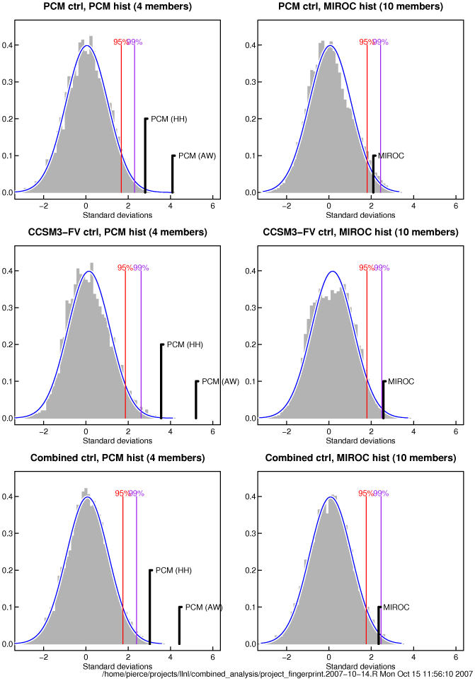
Figure S1. The statistical significance of the signal strength in various anthropogenically forced model runs, taken in combination with the two estimates of natural internal variability from the control runs, as indicated by each panel’s title.
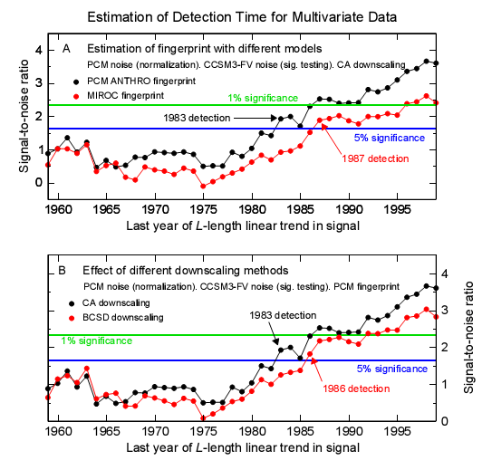
Figure S2. Effect of using different model fingerprints (top) and downscaling methods (bottom) on the detection time.
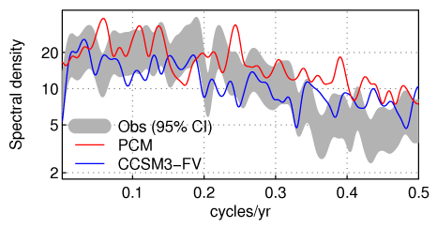
Figure S3. Power spectra of Colorado River flow at Lee’s Ferry. Grey: 95% confidence interval on flow reconstructed from proxy indicators over a 1200 yr period (11). Red: spectrum from PCM control run. Blue: spectrum from CCSM3-FV control run.

